Lab 3
Supplier
SupplierID | Name | Address
S01 | ABC Company | Penang
S02 | XYZ Company | Johor
S03 | HJK Company | Selangor
S04 | PQR Company | Selangor

Primary key: SupplierID

Product
ProductID | Name | Price_RM | QuantityInStock
P01 | Keyboard | 103.55 | 60
P02 | Mouse | 30.90 | 70
P03 | Monitor | 200 | 80
P04 | Pendrive | 40.30 | 50

Primary key: ProductID

Supplies
SuppliesID | SupplierID | ProductID | SuppliedDate | QuantitySupplied
001 | S01 | P01 | 11/ 1/17 | 100
002 | S01 | P02 | 22/2/2017 | 200
003 | S01 | P03 | NULL | 300
004 | S02 | P03 | 30/4/2017 | 400

Primary key: SuppliesID
Foreign Key: SupplierID, ProductID

- Using Ms SQL Server, create a new database Lab3
- Write query to create the tables given above
- Write query to add each row of data into the tables

Attributes | Data Type
SupplierID | nvarchar(50)
Name | nvarchar(50)
Address | nvarchar(50)

Attributes | Data Type
ProductID | nvarchar(50)
Name | nvarchar(50)
Price_RM | decimal(10,2)
QuantityInStock | integer

Attributes | Data Type
SuppliesID | nvarchar(50)
SupplierID | nvarchar(50)
ProductID | nvarchar(50)
SuppliedDate | date
QuantitySupplied | integer

Reference:
https://www.w3schools.com/sql/default.asp

- Generate the database diagram
If you are using Lab PC (or if you’re not using the Admin account), execute the statement below (no need to execute if you’re using own PC/using admin account), this is to grant Admin access to the functions to create database diagram

Alter Authorization on Database::Lab3 To [sa];
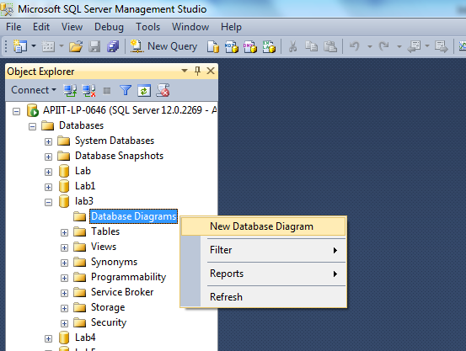

- Using SQL ‘Select’:
  - Display data from all columns from the supplier table
  - Display only product name and price from product table

- Using SQL ‘Select Distinct’:
  - Display only the DISTINCT values from the "Address" column in the Supplier table

- Using SQL ‘IS NULL’, ‘IS NOT NULL’
  - Display all records from Supplies table where SuppliedDate is a null
  - Display all records from Supplies table where SuppliedDate is not a null

